Test Project
  - <Mobile Applications Development>

  - Competition 2026(Guangzhou, China)
  - Module KR
(2.5 hours)

Contents
Contents 2
Introduction 4
Description of project and tasks 4
1. General Requirements 6
1. Description 6
2. Navigation Sidebar & Common 7
1. Description: 7
2. Requirements 7
3. Dashboard Page 8
1. Page Description: 8
2. Requirements 8
4. Scene Page 10
1. Page Description: 10
2. Requirements 10
5. Scene Detail Page(Basic info) 12
1. Page Description: 12
2. Requirements 12
6. Scene Detail Page(Resources) 14
1. Page Description: 14
2. Requirements 14
7. Scene Detail Page(Checklist) 16
1. Page Description: 16
2. Requirements 16
8. Schedule Page 17
1. Page Description: 17
2. Requirements 17
9. Props Page (Resources) 19
1. Page Description: 19
2. Requirements 19
10. Cast Page (Resources) 21
1. Page Description: 21
2. Requirements 21
11. Extras Page (Resources) 23
1. Page Description: 23
2. Requirements 23
12. Locations Page (Resources) 25
1. Page Description: 25
2. Requirements 25
Instructions to the Competitor 27

Introduction
SceneReady is a tablet-based application designed to support short film production by managing scenes, shooting schedules, resources, and checklist-based preparation status.
It enables production teams to efficiently organize and track preparation tasks within a limited time frame, providing features such as scene-based management, schedule tracking, resource monitoring, and checklist-driven progress control.
The application includes scene listing and detailed views, schedule-based workflow management, resource tracking, checklist progress handling, and storyboard reference functionality.
For this task, competitors must implement the core functionalities of the short film production management system based on the provided data files and interface design.

Description of project and tasks
Competitors must use the provided wireframes and files to implement all requirements specified in the task.
The task consists of a single module, and competitors must complete and submit the entire application within the allocated time.
Once the submission time for a module has passed, submitted files cannot be modified.

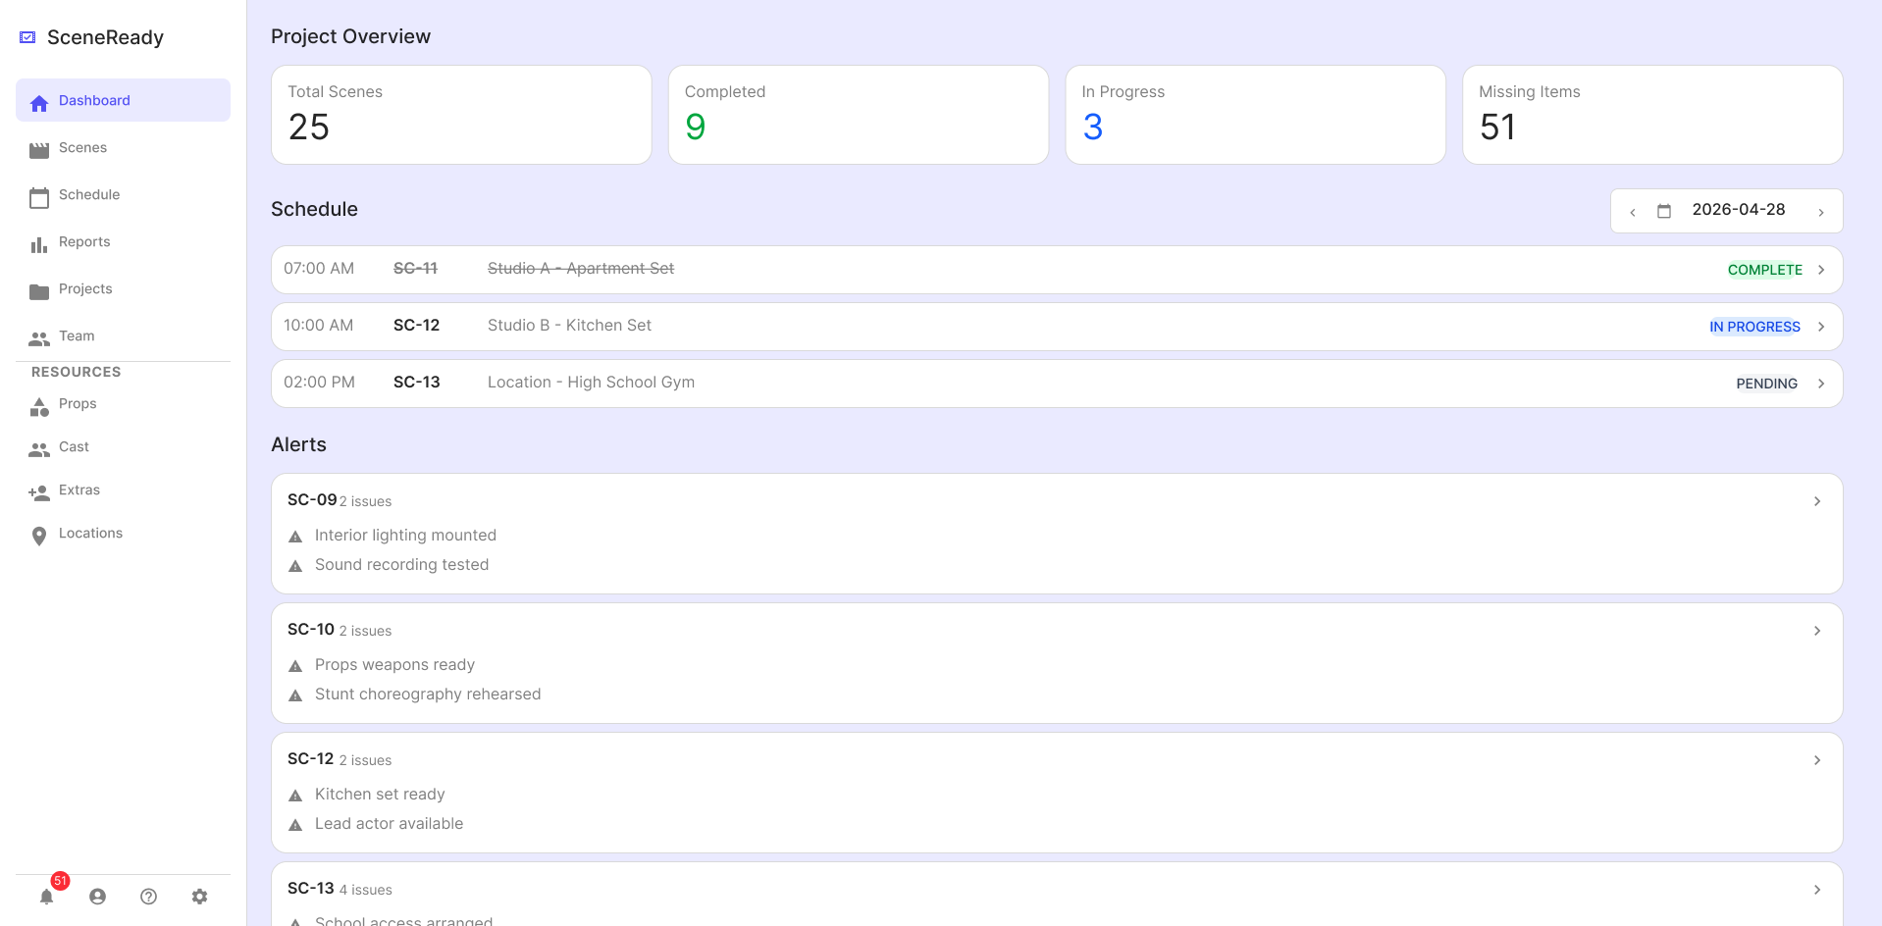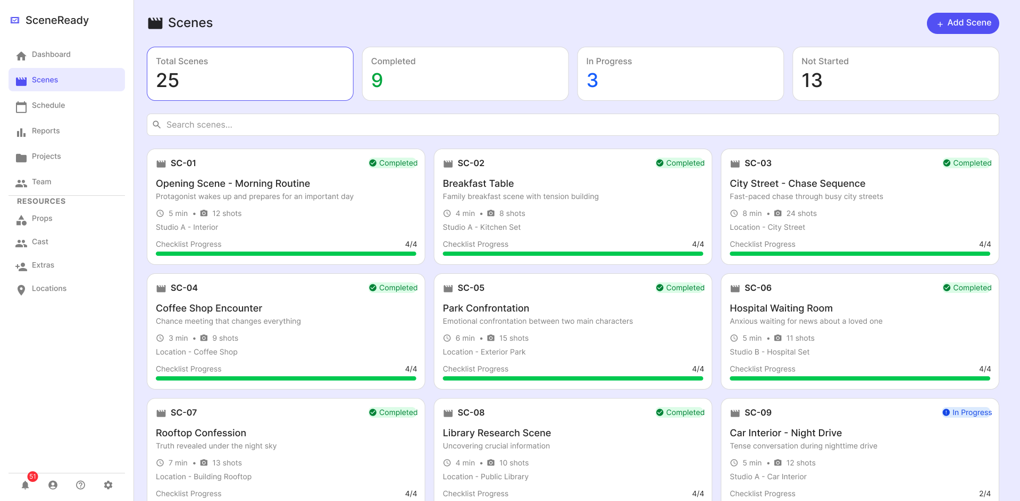
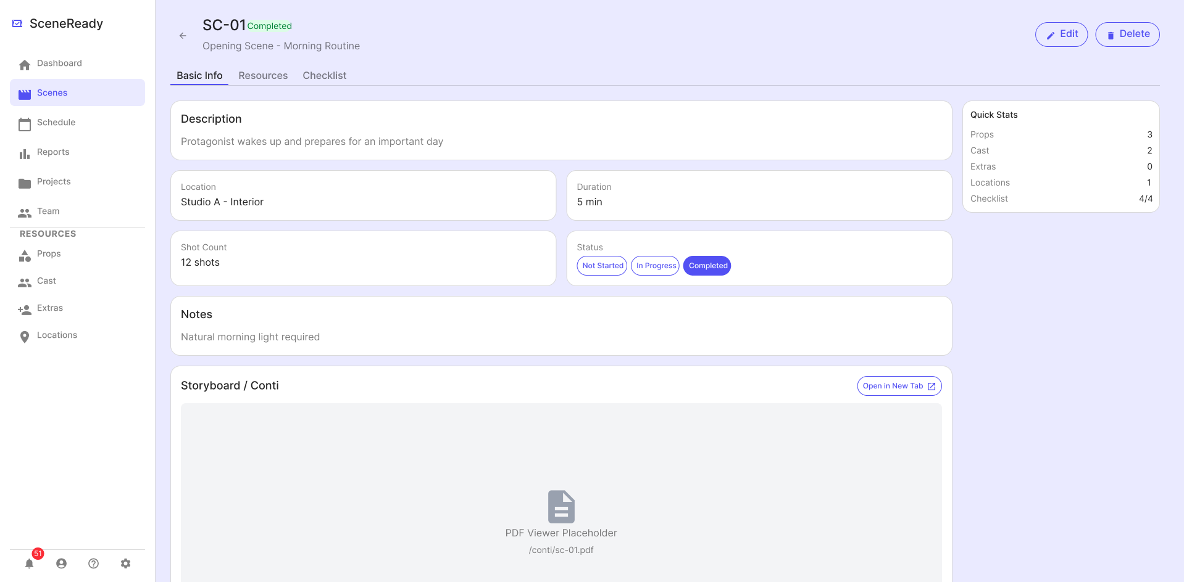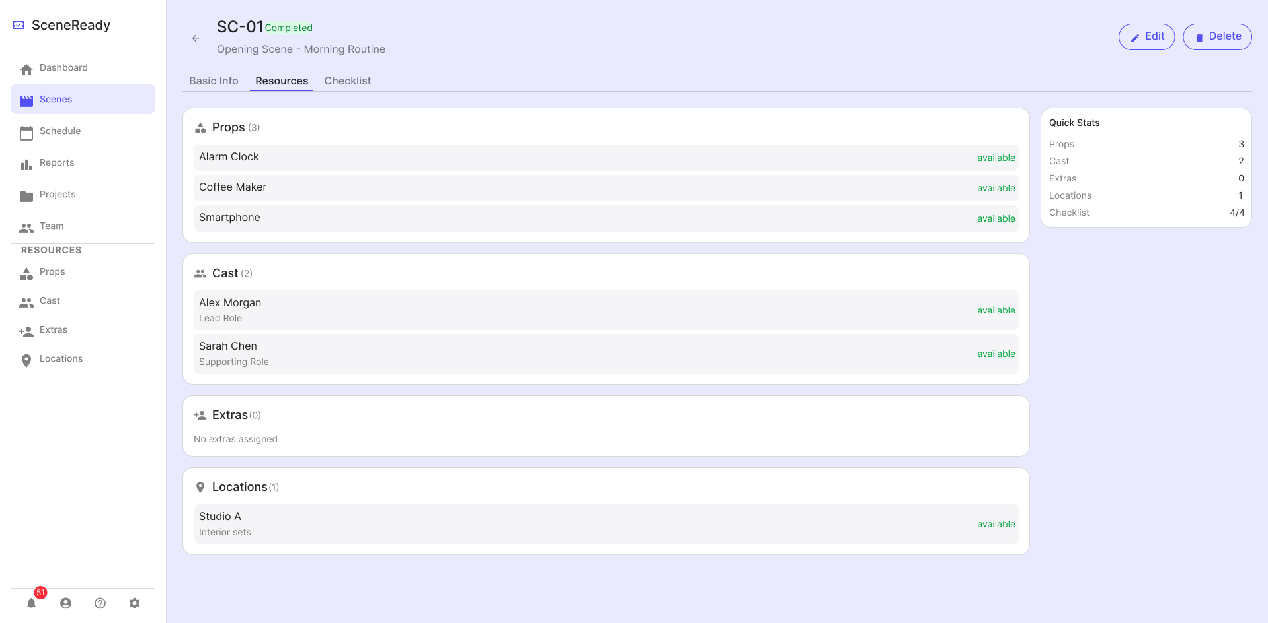
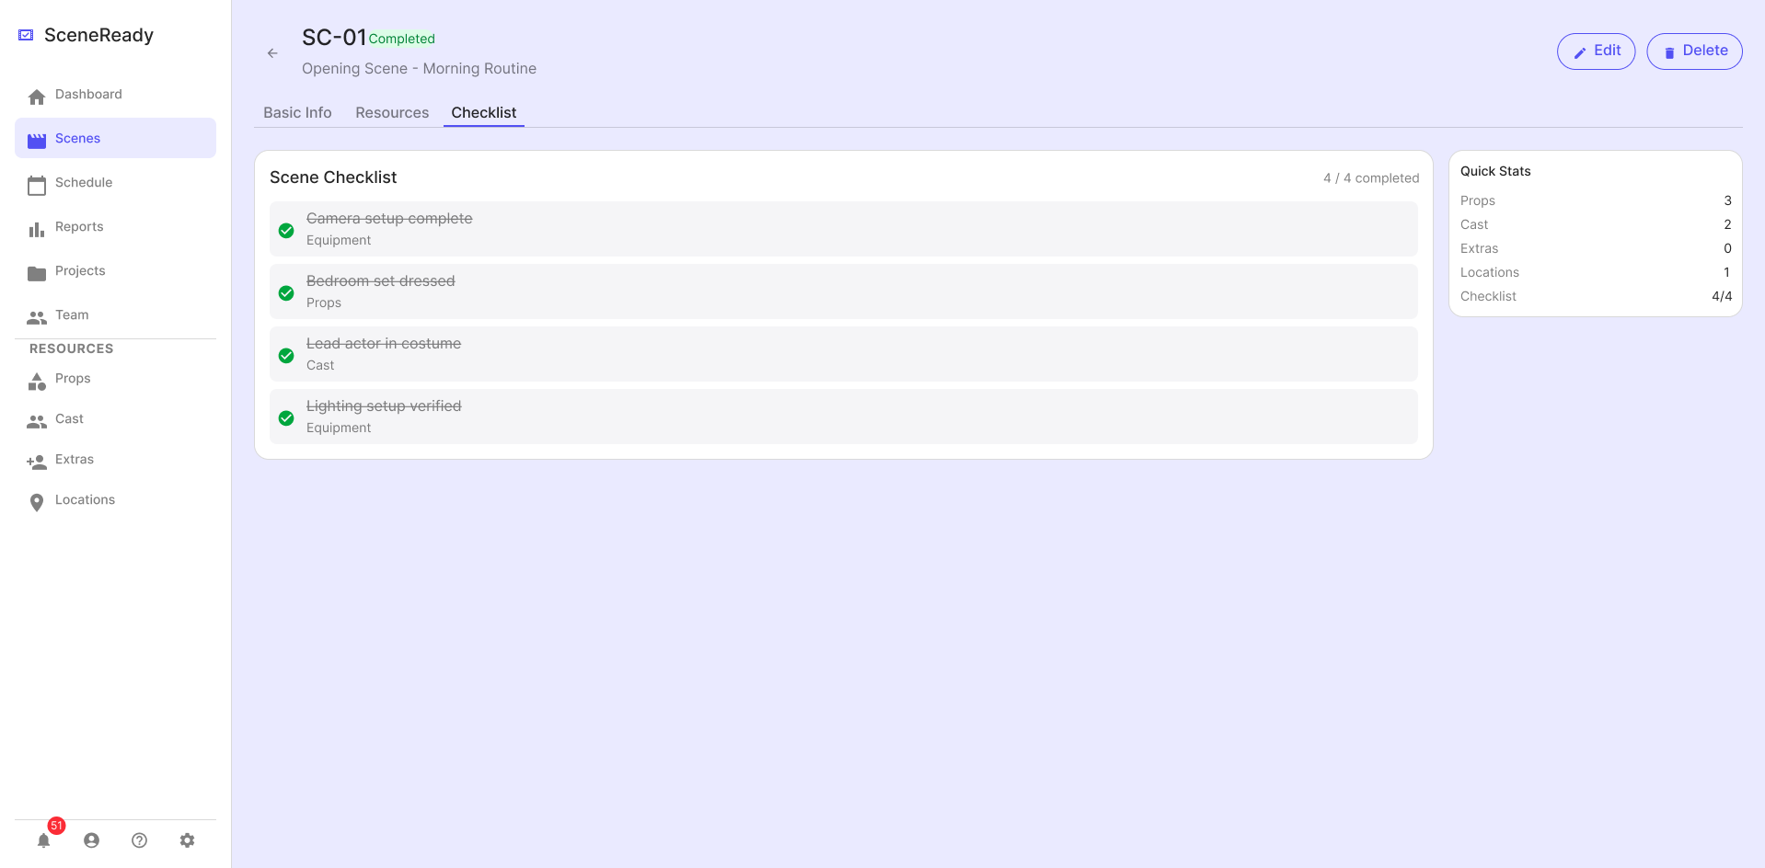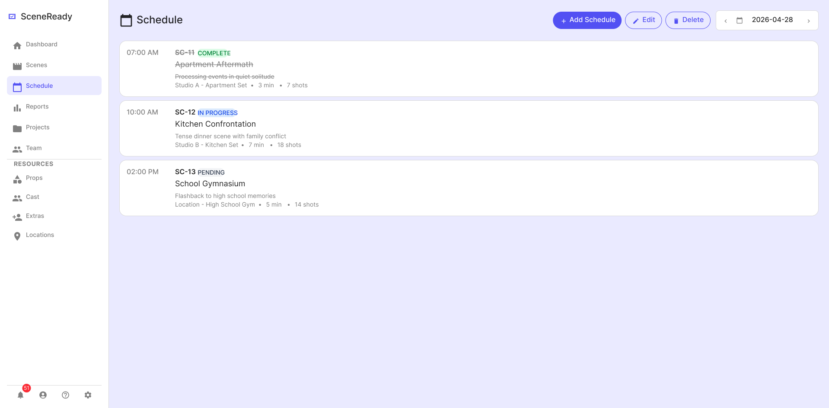
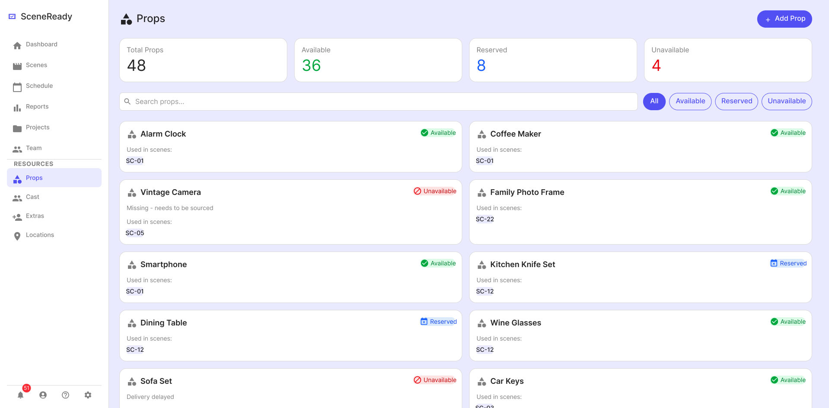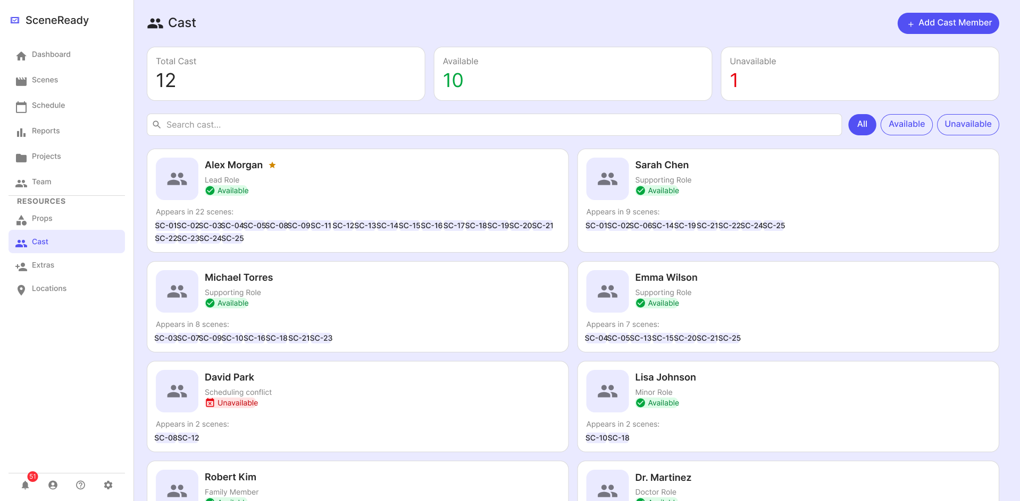
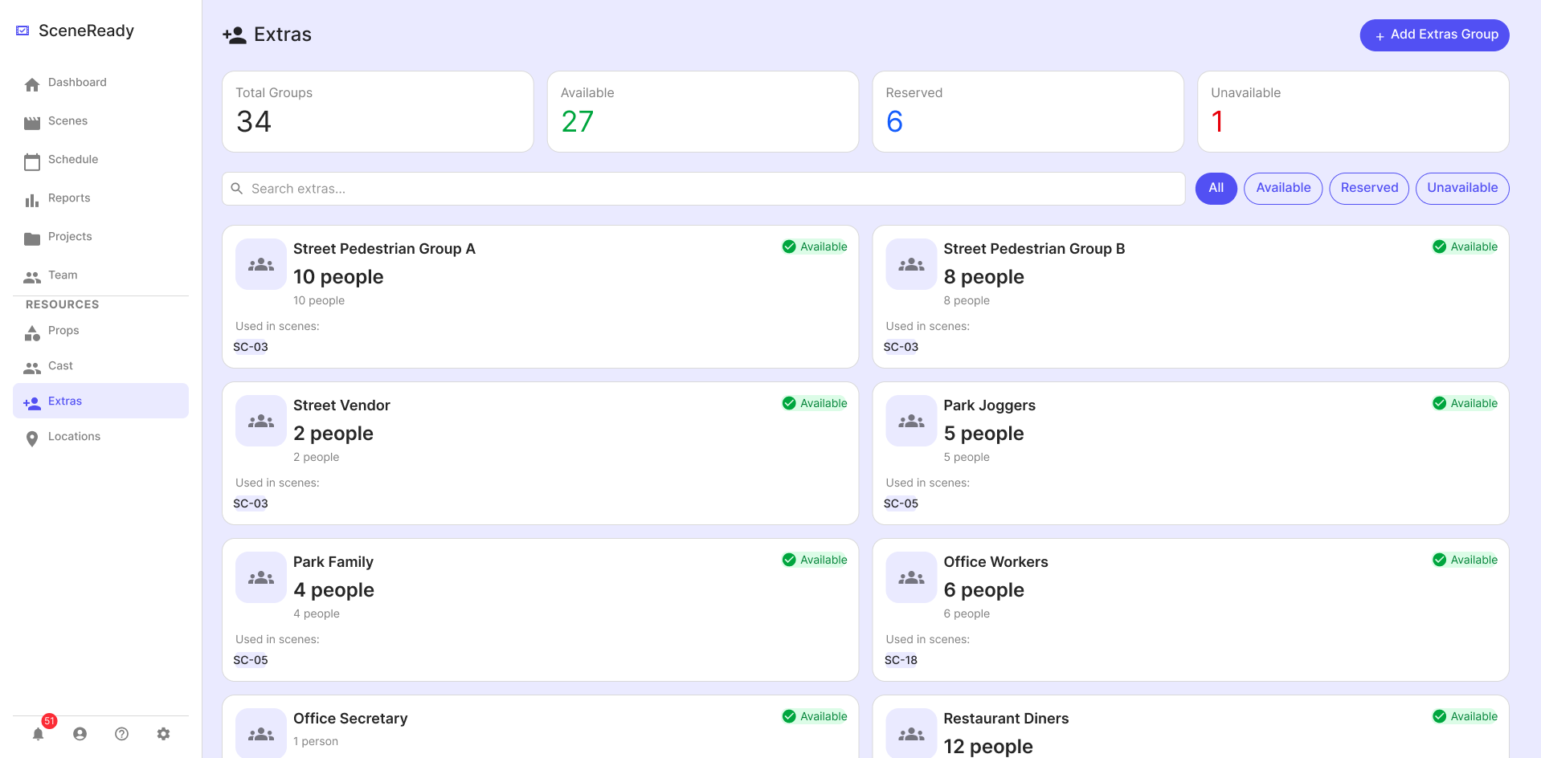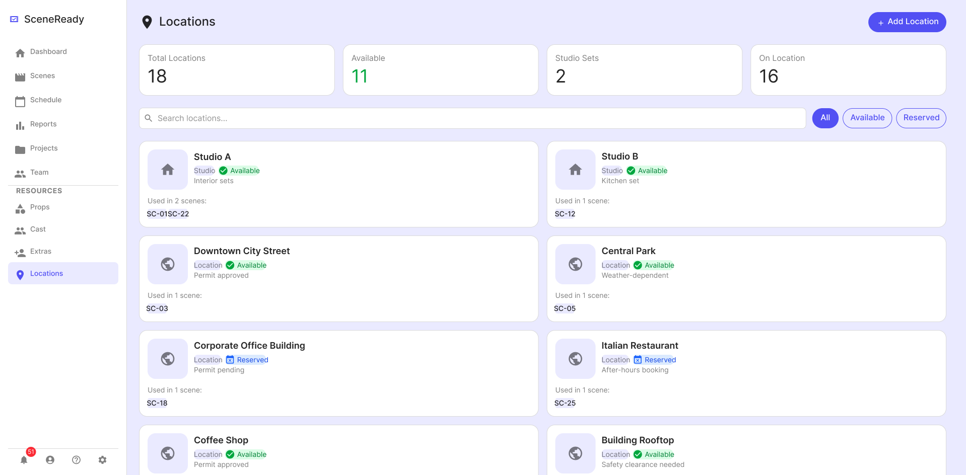
<Wireframes>

1. General Requirements

1. Description
  - Competitors are not allowed to use any external libraries other than the default ones provided.
  - Competitors must refer to the provided wireframe and data files, and implement all required functionalities accordingly.
  - Margins, layouts, colours, fonts, and text do not have to be 100% identical to the wireframe, but should be implemented as similarly as possible.
  - This task does not require any external API or server communication. All functionalities must be implemented using the provided JSONcompleted data.
  - If there are undefined or missing elements in the wireframe, competitors must implement them following standard mobile application UI/UX principles.
  - Competitors may use all files included in the "media-files" folder.
  - Friendly and user-centered messages should be used for error handling, guidance, and validation.
  - The final APK, APP will be evaluated on the provided Tablet AVD(Simulator) and must function correctly in that environment.
  - No user account or authentication mechanism is required for this task.
  - If there are any discrepancies between the provided Test Project (TP) and the video (mp4), the Test Project (TP) must be followed.

2. Navigation Sidebar & Common

1. Description:
  - When the app starts, the Dashboard page is visible.
  - Reports, Projects, and Team pages are not required to be implemented.

2. Requirements
elements | 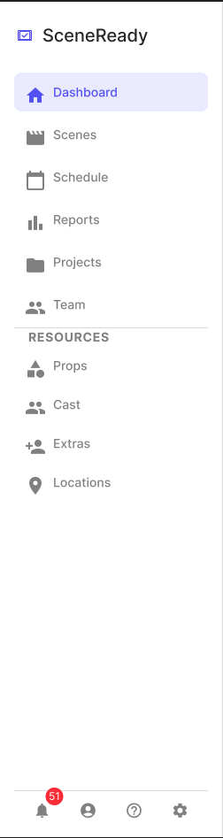
- Symbol & Text: "SceneReady"
- Menu item: "Dashboard” & icon
- Menu item: "Scenes” & icon
- Menu item: "Schedule” & icon
- Menu item: "Reports” & icon
- Menu item: "Projects” & icon
- Menu item: "Team” & icon
- Section label text: "RESOURCES”
- Menu item: "Props” & icon
- Menu item: "Cast” & icon
- Menu item: "Extras” & icon
- Menu item: "Locations” & icon
[Bottom Utility Area]
- Notification icon button
- Notification badge (number indicator)
- User/Profile icon button
- Help icon button
- Settings icon button
REQUIREMENTS
- When the app starts, the Dashboard page is visible.
- When a menu item is clicked, navigate to the corresponding page. (Dashboard, Scenes, Schedule, RESOURCES)
- The selected menu item must be visually highlighted.
- The navigation sidebar must remain fixed and visible at all times.

3. Dashboard Page

1. Page Description:
  - It consists of the Project Overview area, Schedule area, and Alerts area.
  - The Dashboard provides a summary of scene progress, today’s schedule, and pending issues.

2. Requirements

ELEMENTS | REQUIREMENTS
[Project Overview Area]  - Title text: “Project Overview”  - Card: “Total Scenes” text & value  - Card: “Completed” text & value  - Card: “In Progress” text & value  - Card: “Missing Items” text & value  [Schedule Area]  - Title text: “Schedule”  - Date selector button  - Each schedule item include:  - Time text  - Scene code text  - Location text  - Status label  [Alerts Area]  - Title text: “Alerts”  - Each alert item include:  - Scene code text  - Issue count text  - Issue list text. | [Project Overview Area]  - The Project Overview Area is implemented based on the provided JSON data.  [Schedule Area]  - The Schedule Area is implemented based on the provided JSON data.  - Users can navigate to the previous or next day by clicking the navigation buttons.  - When the date selector buttons are clicked, a date selection list must be displayed.  - When a date is selected, the schedule list must update accordingly.  - The schedule list must be displayed in chronological order based on time.  - When a schedule item is clicked, it must navigate to the corresponding Scene Detail page.  [Alerts Area]  - The Alerts Area is implemented based on the provided JSON data.  - When an alert item is clicked, it must navigate to the Checklist tab of the corresponding Scene Detail page(Checklist tab selected)).

4. Scene Page

1. Page Description:
  - The Scenes page displays a list of all scenes based on the provided JSON data.
  - It provides summary information, search functionality, and scene status filtering.

2. Requirements

ELEMENTS | REQUIREMENTS
[Header Area]  - Page title text: “Scenes” with icon  - Button: “Add Scene” with icon  [Summary Cards & Search]  - Card: “Total Scenes” text & value  - Card: “Completed” text & value  - Card: “In Progress” text & value  - Card: “Not Started” text & value  - Search input field (placeholder: “Search scenes…”) with icon  [Scene List Area] Each scene card must include:  - Scene code text (e.g., SC-01)  - Scene title text  - Scene description text  - Duration text  - Shot count text  - Location text  - Status label with icon  - Checklist progress text (e.g., 2/4)  - Checklist progress bar | - All data must be displayed based on the provided JSON data.  [Summary Cards]  - “Total Scenes” must display the total number of scenes.  - “Completed” must display the number of scenes with status “completed”.  - “In Progress” must display the number of scenes with status “in-progress”.  - “Not Started” must display the number of scenes with status “not-started”.  - When a summary card is selected, the scene list must be filtered by the corresponding status.  - The selected summary card must be visually highlighted.  [Search Area & Scene List Area]  - Each scene must be displayed as a card.  - The scene status must be displayed as a label on each card.  - The checklist progress must be calculated based on checklist items.  - The progress bar must reflect the checklist completion ratio.  - When text is entered in the search field, the scene list must be filtered by scene title or scene code.  - If no results are found, the message "No scenes found matching your criteria" must be displayed.  - When a scene card is clicked, it must navigate to the corresponding Scene Detail page (Basic Info tab selected).
\

5. Scene Detail Page(Basic info)

1. Page Description:
  - It displays detailed information of the selected scene based on the provided JSON data.
  - It consists of the Header area, Tab area, Basic Info area, Quick Stats area, and Storyboard / Conti area.
  - The Storyboard / Conti area displays PDF content only when a PDF file is available.

2. Requirements

ELEMENTS | REQUIREMENTS
[Header Area]  - Back icon button  - Scene code text (e.g., SC-01)  - Status label  - Scene title text  - Button: “Edit” with icon  - Button: “Delete” with icon  [Tab Area]  - Tab: “Basic Info”  - Tab: “Resources”  - Tab: “Checklist”  [Basic Info Area]  - Section title text: “Description”  - Scene description text  - Section title text: “Location”  - Location text  - Section title text: “Duration”  - Duration text  - Section title text: “Shot Count”  - Shot count text  - Section title text: “Status”  - Status selection buttons  - Section title text: “Notes”  - Notes text  [Quick Stats Area]  - Section title text: “Quick Stats”  - Props count text  - Cast count text  - Extras count text  - Locations count text  - Checklist progress text (e.g., 4/4)  [Storyboard / Conti Area]  - Section title text: “Storyboard / Conti”  When PDF exists:  - PDF viewer container  - Button: “Open in New Tab” with icon  When PDF does not exist:  - Empty state (no storyboard content displayed | - All data must be displayed based on the provided JSON data.  - The “Basic Info” tab must be visually highlighted as the selected tab.  [Header Area]  - The scene code, title, and status must be displayed based on the selected scene.  - When the back button is clicked, it must navigate to the Scenes page.  [Tab Area]  - The “Basic Info” tab must be selected by default.  - When a tab is clicked, the corresponding content must be displayed.  [Basic Info Area]  - The status selection buttons must reflect the current scene status.  - The selected status must be preserved even after the application is restarted.  [Quick Stats Area]  - All counts must be calculated based on the related data (props, cast, extras, locations).  - Checklist progress must be calculated based on checklist items.  [Storyboard / Conti Area]  - The Storyboard / Conti area must be implemented based on the provided JSON data.  - If a PDF file exists for the scene, the PDF content must be displayed in the viewer area.  - If no PDF file exists, the Storyboard / Conti area must not display any PDF content.  - When the “Open in New Tab” button is clicked, the PDF must be displayed in a larger full-screen view.

6. Scene Detail Page(Resources)

1. Page Description:
  - It displays all resources assigned to the selected scene based on the provided JSON data.
  - It consists of Props, Cast, Extras, and Locations sections.

2. Requirements

ELEMENTS | REQUIREMENTS
[Props Area]  - Section title text: “Props” with count  - Prop name text  - Availability status text  [Cast Area]  - Section title text: “Cast” with count  - Cast name text  - Cast role text  [Extras Area]  - Section title text: “Extras” with count  - Extra description text  When no extras exist:  - Empty state text (e.g., “No extras assigned”)  [Locations Area]  - Section title text: “Locations” with count  - Location name text  - Location description text  - Availability status text | - All data must be displayed based on the provided JSON data.  - The “Resources” tab must be visually highlighted as the selected tab.  [Resources Area]  - Each resource type (Props, Cast, Extras, Locations) must be displayed in separate sections.  [Props Area]  - All props assigned to the selected scene must be displayed.  - Each prop must display its availability status.  [Cast Area]  - All cast assigned to the selected scene must be displayed.  - Each cast must display their role information.  [Extras Area]  - All extras assigned to the selected scene must be displayed.  - If no extras are assigned, an empty state message must be displayed.  [Locations Area]  - All locations assigned to the selected scene must be displayed.  - Each location must display its availability status.

7. Scene Detail Page(Checklist)

1. Page Description:
  - It displays the checklist items of the selected scene based on the provided JSON data.
  - It allows users to check and uncheck items to update the completion status.

2. Requirements

ELEMENTS | REQUIREMENTS
[Checklist Area]  - Section title text: “Scene Checklist”  - Checklist progress text (e.g., 4 / 4 completed)  [Checklist Item] Each item must include:  - Checkbox Checkbox  - Checklist item text  - Category text (e.g., Equipment, Props, Cast) | - The “Checklist” tab must be visually highlighted as the selected tab.  [Checklist Area]  - All checklist items for the selected scene must be displayed.  - Each checklist item must display its category.  - When a checklist item is clicked, its status must toggle between completed and not completed.  - The checklist progress must update accordingly.  - The checklist status must be preserved even after the application is restarted.

8. Schedule Page

1. Page Description:
  - It displays the schedule list based on the provided JSON data.
  - It allows users to navigate schedules by date using previous, next, and date selection controls.

2. Requirements

ELEMENTS | REQUIREMENTS
[Header Area]  - Page title text: “Schedule” with icon  - Button: “Add Schedule” with icon  - Button: “Edit” with icon  - Button: “Delete” with icon  - Previous date button  - Date selector button with icon  - Current date text  - Next date button  [Schedule Item] Each item must include:  - Time text (e.g., 07:00 AM)  - Scene code text (e.g., SC-11)  - Status label  - Scene title text  - Scene description text  - Location text  - Duration text  - Shot count text  [Date Selection List]  - Date selection list container  - Date item text  - Scene count text for each date | - All data must be displayed based on the provided JSON data.  - The “Schedule” menu must be visually highlighted as the selected menu.  - When a schedule item is clicked, it must navigate to the corresponding Scene Detail page.  [Schedule List Area]  - All schedule items must be displayed based on the provided JSON data.  - The schedule list must be filtered by the selected date.  - The schedule list must be displayed in chronological order based on time.  [Date Navigation]  - When the previous date button is clicked, the schedule date must change to the previous available date.  - When the next date button is clicked, the schedule date must change to the next available date.  - When the date is changed, the schedule list must update accordingly.  [Date Selection List]  - When the date selector button is clicked, a date selection list must be displayed.  - The date selection list must display all available dates based on the provided JSON data.  - Each date item must display the number of scenes for that date.  - When a date item is clicked, the selected date must be updated accordingly.  - The selected date in the list must be visually highlighted.  - When a date is selected, the schedule list must update accordingly.

9. Props Page (Resources)

1. Page Description:
  - It displays all props based on the provided JSON data.
  - It allows users to search and filter props by availability status.

2. Requirements

ELEMENTS | REQUIREMENTS
[Header Area]  - Page title text: “Props” with icon  - Button: “Add Prop” with icon  [Summary Cards]  - Card: “Total Props” text & value  - Card: “Available” text & value  - Card: “Reserved” text & value  - Card: “Unavailable” text & value  [Search & Filter Area]  - Search input field (placeholder: “Search props…”)  - Filter button: “All”  - Filter button: “Available”  - Filter button: “Reserved”  - Filter button: “Unavailable”  [Prop Item] Each item must include:  - Prop name text  - Description text  - “Used in scenes” text  - Scene code text  - Status label with icon | - The “Props” menu must be visually highlighted as the selected menu.  [Summary Cards]  - All summary values must be calculated based on the provided JSON data.  [Search & Filter Area]  - When text is entered in the search field, the props list must be filtered by prop name.  - When a filter button is selected, the props list must be filtered by the corresponding status  - The selected filter button must be visually highlighted.  [Props List Area]  - All props must be displayed based on the provided JSON data.  - Each prop must be displayed as a card.  - Each prop must display its availability status.  - When a scene code in the “Used in scenes” section is clicked, it must navigate to the corresponding Scene Detail page with the Resources tab selected.

10. Cast Page (Resources)

1. Page Description:
  - It displays all cast based on the provided JSON data.
  - It allows users to search and filter cast by availability status.

2. Requirements

ELEMENTS | REQUIREMENTS
[Header Area]  - Page title text: “Cast” with icon  - Button: “Add Cast Member” with icon  [Summary Cards]  - Card: “Total Cast” text & value  - Card: “Available” text & value  - Card: “Unavailable” text & value  [Search & Filter Area]  - Search input field (placeholder: “Search cast…”)  - Filter button: “All”  - Filter button: “Available”  - Filter button: “Unavailable”  [Cast Item] Each item must include:  - Cast image or placeholder icon  - Cast name text  - Description text  - Status label with icon  - “Appears in scenes” text  - Scene code text | - The “Cast” menu must be visually highlighted as the selected menu.  [Summary Cards]  - All summary values must be calculated based on the provided JSON data.  [Search & Filter Area]  - When text is entered in the search field, the cast list must be filtered by cast name.  - When a filter button is selected, the cast list must be filtered by the corresponding status.  - The selected filter button must be visually highlighted.  [Cast List Area]  - All cast members must be displayed based on the provided JSON data.  - Each cast member must be displayed as a card.  - Each cast member must display its availability status.  - When a scene code in the “Appears in scenes” section is clicked, it must navigate to the corresponding Scene Detail page with the Resources tab selected.

11. Extras Page (Resources)

1. Page Description:
  - It displays all extras based on the provided JSON data.
  - It allows users to search and filter extras by availability status.

2. Requirements

ELEMENTS | REQUIREMENTS
[Header Area]  - Page title text: “Extras” with icon  - Button: “Add Extras Group” with icon  [Summary Cards]  - Card: “Total Groups” text & value  - Card: “Available” text & value  - Card: “Reserved” text & value  - Card: “Unavailable” text & value  [Search & Filter Area]  - Search input field (placeholder: “Search extras…”)  - Filter button: “All”  - Filter button: “Available”  - Filter button: “Reserved”  - Filter button: “Unavailable”  [Extras Item] Each item must include:  - Extras group icon or placeholder  - Extras group name text  - Number of people text (e.g., “10 people”)  - Description text  - “Used in scenes” text  - Scene code text  - Status label with icon | - The “Extras” menu must be visually highlighted as the selected menu.  [Summary Cards]  - All summary values must be calculated based on the provided JSON data.  [Search & Filter Area]  - When text is entered in the search field, the extras list must be filtered by group name.  - When a filter button is selected, the extras list must be filtered by the corresponding status.  - The selected filter button must be visually highlighted.  [Extras List Area]  - All extras groups must be displayed based on the provided JSON data.  - Each extras group must be displayed as a card.  - Each extras group must display its availability status.  - When a scene code in the “Used in scenes” section is clicked, it must navigate to the corresponding Scene Detail page with the Resources tab selected.

12. Locations Page (Resources)

1. Page Description:
  - It displays all locations based on the provided JSON data.
  - It allows users to search and filter locations by availability status.
  - Location types must be determined based on the location name: locations containing "Studio" must be treated as Studio Sets, and all others as On Location.

2. Requirements

ELEMENTS | REQUIREMENTS
[Header Area]  - Page title text: “Locations” with icon  - Button: “Add Location” with icon  [Summary Cards]  - Card: “Total Locations” text & value  - Card: “Available” text & value  - Card: “Studio Sets” text & value  - Card: “On Location” text & value  [Search & Filter Area]  - Search input field (placeholder: “Search locations…”)  - Filter button: “All”  - Filter button: “Available”  - Filter button: “Reserved”  [Location Item] Each item must include:  - Location icon or placeholder  - Location name text  - Location type text  - Description text  - Status label with icon  - “Used in scenes” text  - Scene code text | - The “Locations” menu must be visually highlighted as the selected menu.  [Summary Cards]  - All summary values must be calculated based on the provided JSON data.  [Search & Filter Area]  - When text is entered in the search field, the locations list must be filtered by location name.  - When a filter button is selected, the locations list must be filtered by the corresponding status.  - The selected filter button must be visually highlighted.  [Locations List Area]  - All locations must be displayed based on the provided JSON data.  - Each location must be displayed as a card.  - Each location must display its availability status.  - When a scene code in the “Used in scenes” section is clicked, it must navigate to the corresponding Scene Detail page with the Resources tab selected.

Instructions to the Competitor
- Competitors must build the final APK file, and the APK file must be placed in the root directory of the source project.
※ Final file name: Module_KR_{XX}.apk or Module_KR_{XX}.app (where XX represents the competitor’s workshop number)
- The project source directory must be pushed to the provided VCS (Gitea) repository.
- Only the materials submitted within the given competition time will be evaluated. (Submission must also be completed within the competition time)
- Evaluation will be conducted based on the submitted APK/APP file. (Execution may be performed if necessary)

